SORU 1:
Imports System.IO

Public Class Form1
Private Sub btnHesapla_Click(sender As Object, e As EventArgs) Handles btnHesapla.Click
If txtAdet.Text = "" Or txtBirimFiyat.Text = "" Or txtUrunAd.Text = "" Then
MsgBox("İlgili alanları doldurunuz !")
Return
End If
Dim dosya As New StreamWriter("KDV.txt")
Dim kdvDurum As String = "dahil degil"
If chKdv.Checked Then
kdvDurum = "dahil"
End If
dosya.WriteLine(txtUrunAd.Text + "," + txtBirimFiyat.Text + "," + txtAdet.Text + "," + kdvDurum)
dosya.Close()
MsgBox("Kaydedildi.")
End Sub
End Class

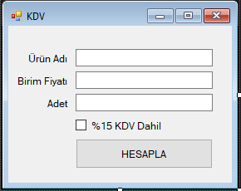

SORU2:
Imports System.IO

Public Class Form1
Dim ogrenciNo As String = ""
Dim secilenIndex As Integer = -1
Private Sub Listele()
lstVeri.Items.Clear()
Dim dosyaAdi As String = "ogrenci.txt"

For Each satir As String In File.ReadLines(dosyaAdi)

Dim veri = satir.Split(",")
Dim veriler As New ListViewItem
veriler.Text = veri(0)
veriler.SubItems.Add(veri(1))
veriler.SubItems.Add(veri(2))

lstVeri.Items.Add(veriler)
Next satir

End Sub

Private Sub Yazdir()

File.CreateText("ogrenci.txt").Close()

Dim dosya As New StreamWriter("ogrenci.txt")

For index = 0 To lstVeri.Items.Count - 1
Dim satir As String = lstVeri.Items(index).SubItems(0).Text + "," + lstVeri.Items(index).SubItems(1).Text + "," + lstVeri.Items(index).SubItems(2).Text
dosya.WriteLine(satir)

Next
dosya.Close()

ogrenciNo = ""
txtOgrenciNo.Text = ""
txtAd.Text = ""
txtSoyad.Text = ""
secilenIndex = -1

Listele()
End Sub
Private Sub Form1_Load(sender As Object, e As EventArgs) Handles MyBase.Load
Listele()

End Sub

Private Sub lstVeri_DoubleClick(sender As Object, e As EventArgs) Handles lstVeri.DoubleClick
txtOgrenciNo.Text = lstVeri.Items(lstVeri.SelectedIndices(0)).SubItems(0).Text
txtAd.Text = lstVeri.Items(lstVeri.SelectedIndices(0)).SubItems(1).Text
txtSoyad.Text = lstVeri.Items(lstVeri.SelectedIndices(0)).SubItems(2).Text
ogrenciNo = txtOgrenciNo.Text
secilenIndex = lstVeri.SelectedIndices(0)
End Sub

Private Sub btnKaydet_Click(sender As Object, e As EventArgs) Handles btnKaydet.Click

Dim veriler As New ListViewItem
veriler.Text = txtOgrenciNo.Text
veriler.SubItems.Add(txtAd.Text)
veriler.SubItems.Add(txtSoyad.Text)

lstVeri.Items.Add(veriler)
Yazdir()

End Sub

Private Sub btnGuncelle_Click(sender As Object, e As EventArgs) Handles btnGuncelle.Click
If secilenIndex = -1 Then
MsgBox("Kayıt seçiniz")
Return
End If
lstVeri.Items(lstVeri.SelectedIndices(0)).SubItems(0).Text = txtOgrenciNo.Text
lstVeri.Items(lstVeri.SelectedIndices(0)).SubItems(1).Text = txtAd.Text
lstVeri.Items(lstVeri.SelectedIndices(0)).SubItems(2).Text = txtSoyad.Text

Yazdir()

End Sub

Private Sub btnSil_Click(sender As Object, e As EventArgs) Handles btnSil.Click
If secilenIndex = -1 Then
MsgBox("Kayıt seçiniz")
Return
End If
lstVeri.Items.RemoveAt(secilenIndex)

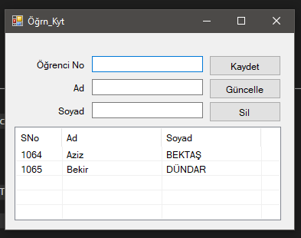
Yazdir()

End Sub
End Class

SORU 3:
Public Class Form1
Dim sayac As Integer = 0
Private Sub Timer1_Tick(sender As Object, e As EventArgs) Handles Timer1.Tick
sayac += 1
txtSure.Text = sayac.ToString
If sayac = 15 Then
Timer1.Stop()
MsgBox("Süre aşımı")
Me.Close()
End If
End Sub

Private Sub Button2_Click(sender As Object, e As EventArgs) Handles btnHesapla.Click
Timer1.Stop()
Dim toplam As Double = 0
Dim adet As Integer = 0
Dim sonuc As String = ""
If RadioButton1.Checked Then
For index = 0 To lstSayilar.Items.Count - 1
If Convert.ToInt32(lstSayilar.Items(index)) < 0 Then
toplam = toplam + Convert.ToInt32(lstSayilar.Items(index))
adet = adet + 1
End If
Next
sonuc = (toplam / adet).ToString()
End If

If RadioButton2.Checked Then
For index = 0 To lstSayilar.Items.Count - 1
If Convert.ToInt32(lstSayilar.Items(index)) > 0 Then
toplam = toplam + Convert.ToInt32(lstSayilar.Items(index))
adet = adet + 1
End If
Next
sonuc = (toplam / adet).ToString()
End If

If RadioButton3.Checked Then
For index = 0 To lstSayilar.Items.Count - 1
toplam = toplam + Convert.ToInt32(lstSayilar.Items(index))
adet = adet + 1
Next
Dim ortalama As Double = toplam / adet
For index = 0 To lstSayilar.Items.Count - 1
If Convert.ToInt32(lstSayilar.Items(index)) > ortalama Then
sonuc = sonuc + " " + lstSayilar.Items(index).ToString
End If
Next
End If

If RadioButton4.Checked Then
For index = 0 To lstSayilar.Items.Count - 1
toplam = toplam + Convert.ToInt32(lstSayilar.Items(index))
adet = adet + 1
Next
Dim ortalama As Double = toplam / adet
For index = 0 To lstSayilar.Items.Count - 1
If Convert.ToInt32(lstSayilar.Items(index)) < ortalama Then
sonuc = sonuc + " " + lstSayilar.Items(index).ToString
End If
Next
End If

Dim form2 As New Form2
form2.Label1.Text = "Sonuç : " + sonuc
form2.ShowDialog()

End Sub

Private Sub btnEkle_Click(sender As Object, e As EventArgs) Handles btnEkle.Click
If txtSayi.Text = "" Then
MsgBox("Sayı giriniz !")
Return
End If
lstSayilar.Items.Add(Convert.ToInt32(txtSayi.Text))
txtSayi.Text = ""

If lstSayilar.Items.Count = 10 Then
txtSayi.Enabled = False
btnEkle.Enabled = False
btnHesapla.Enabled = True
Timer1.Enabled = True
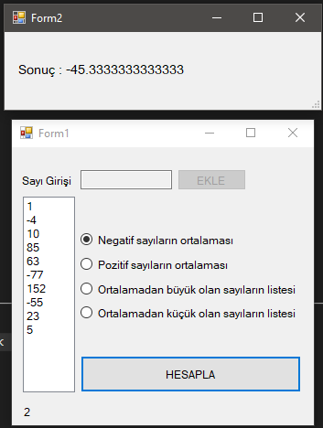
End If
End Sub

Private Sub Form1_Load(sender As Object, e As EventArgs) Handles MyBase.Load
RadioButton1.Checked = True
End Sub
End Class

SORU 4:
Public Class Form1
Private Sub btnCikar_Click(sender As Object, e As EventArgs) Handles btnCikar.Click
Try
Dim baslangic As Integer = Convert.ToInt32(txtBaslangicPozisyon.Text)
Dim cikarilacak As Integer = Convert.ToInt32(txtCikarilacakSayi.Text)
txtSonHal.Text = txtGirilen.Text.Substring(baslangic - 1, cikarilacak)
Catch ex As Exception
MsgBox("Hata : " + ex.Message.ToString)
End Try
End Sub
End Class
